Phonic Screening Check Past Papers
During the summer term, all Year 1 children complete the statutory Phonics Screening Check (PSC). Any child who does not reach the national standard at the end of Year 1 is given extra support during Year 2 to help them achieve the national standard at the end of Key Stage 1.
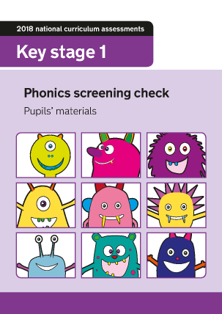

Please find below documents to support the Y1 National Phonics Screening Test. These are past papers for you to use with your child at home.
2023 past paper

2022 past paper
2016 past paper
2017 past paper
2018 past paper
2019 past paper

