Displays and Classroom Organisation
Policy

Our School Mission Statement

In order to achieve success at Fazakerley Primary School, we believe that everyone in our community is of equal worth and should be given the opportunity to develop their full potential intellectually, emotionally, socially, physically and professionally. We promote in our whole school community, an understanding and respect for everyone’s well-being and mental health, valuing and supporting each other as an integral part of our school life.

Aims of Display & Classroom Organisation

At Fazakerley Primary School we aim to:

- Encourage pupils to have pride and confidence in their work and achievements by demonstrating that we value their work and learning
- Create a learning environment that stimulates interest and discussion to challenge children’s knowledge and understanding of the world
- Encourage respect for the school environment and actively work to ensure it is an enriched place to work and learn, in line with our school code of conduct.
- Influence children in best presentation, personal organisation and general tidiness
- Celebrate achievement and raise self-esteem for all
- Use display and resources to positively impact on learning; through consolidation / reminder of previous learning and introducing new information & knowledge.

Expectations of Learning Environments

Display is not intended as decoration, it is there to support and facilitate teaching and learning in the classroom.

It goes without saying, that all displays must be maintained on a very regular basis so that they don’t become tatty and send all who see them the wrong messages. Only by updating displays regularly can you maintain a vibrant environment that reflects the experiences and opportunities you offer the children in your care. Take pride in your room, it is far too easy to give a false impression of the quality of your teaching by a disorganised space.

Teachers are encouraged to delegate some responsibility to named pupils for the upkeep and maintenance of the classroom and general learning environment. Good routines for tidying away are crucial. Classes should not be dismissed to lunch / home until the classroom is tidy.
There should be no empty boards in any classrooms.

Displays around school should be completed to policy standards by the following deadlines:

Deadline | Display
First Day of Autumn term | Classroom Environment List (class family & attendance to be prepared pending photos)
In place before teaching of subject begins | Classroom Displays List
Friday before Autumn Parents Evening | Corridor displays should be fully in place
Friday before Spring Parents Evening | Corridor displays should have been replaced with new work

Classroom Environment

- Fire evacuation procedures (Health & Safety requirement)
- A3 Code of Conduct, pricelist, 4 S poster
- Attendance traffic lights (updated monthly)
- Class Family Display
- Visual daily timetable which is consistent (separate document attached with photo exemplar and example cards)
- The timetable cards have been placed on blue card so that the images can be seen clearly.
- The whole day will be displayed of a morning and the card removed as the lesson/ event is complete.
- The timetable reads from top to bottom with the finished card displayed at the bottom
- No need for a timetable title
- Individual, smaller sized versions may be appropriate for some children.
- This personalised timetable must be implemented on a needs led basis and individualised for the child.
- For example, they might just have the morning lessons displayed or two activities at a time so it does not become overwhelming.
- ROAR Rainbow KS1 KS2 - Colour monster for EYFS
- EYFS & KS1 ‘Time to talk’ board (set template prepared – see appendix 18 & 19)
- KS2 Worry box
- Trays labelled
- Maths help desk including unit appropriate Maths resources
- English help desk resources
- Appealing library/reading area in classrooms which promote reading for pleasure. They should be tidied daily and regularly sorted, either by your LSA or pupils. A ‘Book Board’ in this area which is a changeable display that supports reading for pleasure (if space allows) – see staff drive for details.
- Age-appropriate History Timeline (advised by History Leader).
- Compass points – KS1 4 points, KS2 8 points.
- WORLD map (A3) – KS1 showing continents and oceans, KS2 showing more detail including e.g. the Equator, lines of latitude an longitude etc.
- A UK map (A3) – KS1 showing countries, capitals and surrounding seas, KS2 – in addition, showing counties and regions studied. Chn to use PINS and ‘POST-ITS’ to interact with all maps

In EYFS and KS1 hessian with a black border and black lettering OR a hessian coloured banner (shade attached as separate document) without the use of plastic covering will be used (image below of what is allowed and what isn’t).
In KS2 pastel backing paper which is covered in plastic backing.
There should be no items hanging from the ceiling.
There may be display items which do not fit onto a board. We want to limit items which are on classroom walls to not overwhelm the visual environment.
The surrounding wall area of the IWB and whiteboards should be clear as to not distract from the visual input.

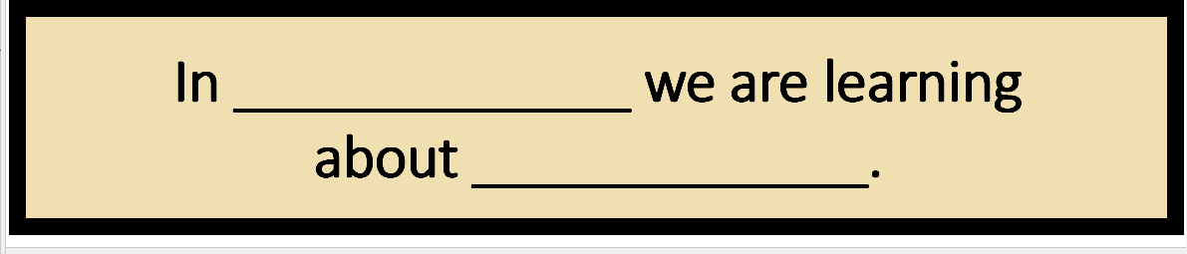
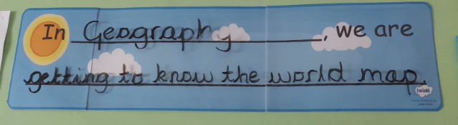
In EYFS and KS1, in line with hessian and muted tones, tabs or items as below to be on white background with a black border and black text not anything colour as below.

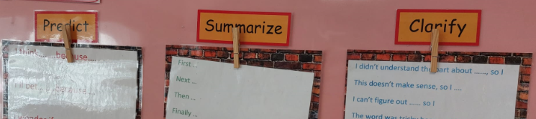

Interactive working walls will be displayed in classrooms to support the teaching and learning of all subjects. The following subjects will always have a working wall in use in all classrooms as they are taught daily or weekly:
KS1 |  | KS2
Maths |  | Maths
English | Reading | English | Reading
English | Writing & SPAG | English | Writing & SPAG
Phonics |  | Spanish
PSHE | Wellbeing | PSHE | Wellbeing
PSHE | Mental Health | PSHE | Mental Health
PSHE | ROAR | PSHE | ROAR
Music |  | Music
The following subjects will be taught in blocks and should have a working wall in use whilst they are being taught:

KS1 | KS2
History | History
R.E. | R.E.
Computing Code | Computing Code
Geography | Geography
Art | Art
Science | Science
DT | DT
For classrooms that have a greater number of display boards, these should be used as learning journey walls. This is where prior learning from previously taught topics can be displayed once taken down from the subject working walls. This will allow prior learning and current learning to be explicitly linked and built upon.
A PE working wall in both halls will have space for year groups 1-6. Teachers will add to their own year group section weekly when PE lessons are happening in the hall.

Please see the appendices for further information on how each subject working wall should be presented and used.

Due to the nature of working walls, it is appropriate to use sticky notes, blutak, string, pegs, temporary shelving i.e. to display artefacts/3D shapes etc.
Corridor and Hall Displays

There will be two types of displays in corridors and halls:

- Celebratory Displays which showcase children’s final pieces of work. These displays must have (see Appendix 1 for templates):
- A title (computer generated or created using stencils and coloured paper / card)
- Learning Objective and short caption that provides context to the display
- Names and ages to be mounted next to or under children’s work
- Optional QR Code with more information if applicable (for example a link to Information about the artist)

- Learning Journey Displays which outline the whole process children have gone through for a specific topic. These displays must have (see Appendix 1 for templates):
- A title (computer generated or created using stencils and coloured paper / card)
- Open / closed questions
- Learning Objective and short caption that provides context to the display
- Process of what the children did in relation to the subject-specific domains (as this will be different for each subject)
- Reinforcement of key vocabulary
- Pupil voice
- Names and ages to be mounted next to or under children’s work
- Optional QR Code showing children’s learning if applicable (for example a link to the children shading their artwork)

Review of the Policy
This policy is reviewed regularly and updated as necessary. Amendments are based on the experiences of recently appointed staff and leaders/mentors and take account of their comments at all stages. If necessary, the policy will be modified during the school year.

Appendix 1

- Name label - print/cut around to include a thin white trim surrounding the black broder to create a double mount ‘look’. Font and size to remain consistent across the display. *size below may be too big and need adjusting

Bob Jones, aged 10

- Pupil voice to be written inside this speech bubble to ensure consistency on all displays. Print/cut around to include a thin white trim surrounding the black border to create a double mount ‘look’.

WALT: Objective to be word processed in this font and size *Print/cut around to include a thin white trim surrounding the black border to create a double mount ‘look’.

Short caption that provides context to the display to be word processed in this font and size
*Print/cut around to include a thin white trim surrounding the black border to create a double mount ‘look’.

Appendix 2 – English MAY CHANGE IN LIGHT OF NEW SCHEME - TBC
You may want a separate board for SPAG and handwriting if you don’t have one big enough to get all of this on as well as all of your genre stuff.
During the teaching of the genre, I used to end up on one of those mobile blue display boards when I could get my hands on them, alternatively we could use a washing line and peg up A3 or flipchart size work in support of the work here (please speak to Joe about placement as I knew not to dangle underneath my ceiling blow heaters)
Some of this may be fixed and just adapted for each genre.

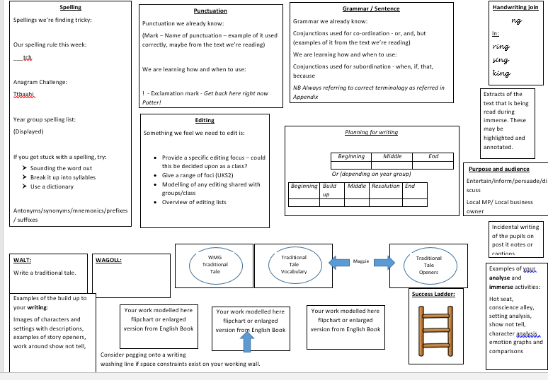
Appendix 3 – PSHE
Learning Charter
To remain up for the year. Remind the children about the learning charter at the start of each lesson.
Weekly Celebration
Jot names on of the children who have achieved the weekly celebration.
Changed weekly and take down the previous weeks as only the current week should be displayed.
Key Vocabulary
Use vocabulary from the lesson plans. Add to the vocabulary area throughout the unit. The vocabulary should remain up for the whole half term.
Refer to the vocabulary constantly.
Vocabulary could be displayed through post sticks, terms and definition, pictures, application within sentences and pupil voice etc.

Jigsaw Charter
To remain up for the year.
Remind the children about the Jigsaw Charter at the start of each lesson.

A class definition of what ‘mental health’ means.

Ways and ideas to keep mentally healthy
Evidence of lessons and learning (lessons 1-6). Keep up for the whole half term.

Puzzle Piece
i.e. Celebrating Difference
To remain up for whole half term.

**In learning charter, give particular reference to not giving out personal information about themselves or family members as thoughts/stories pop up.

Appendix 4 – KS1/KS2 Maths

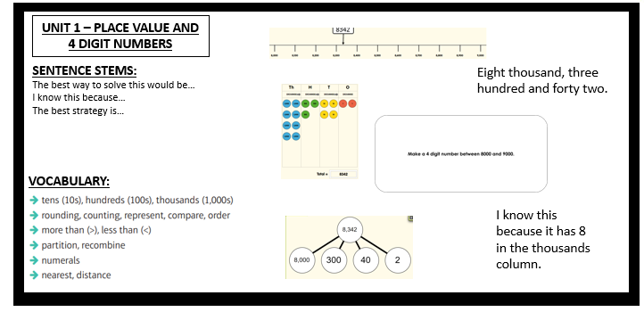

Appendix 5 – Geography

We are learning about ___________ in Geography
UNIT QUESTION: ________________________________
WALT:

Vocabulary:

Appropriate map for the study focus e.g
- World map for continents and oceans
- UK map for capitals, regions, counties, borders, rivers
- World map showing climate zones
- World map showing time zones
- World map showing biomes etc

LOCATIONAL KNOWLEDGE | PLACE KNOWLEDGE | HUMAN & PHYSICAL GEOGRAPHY | GEOGRAPHICAL SKILLS & FIELDWORK
Appendix 6 – Religious Education
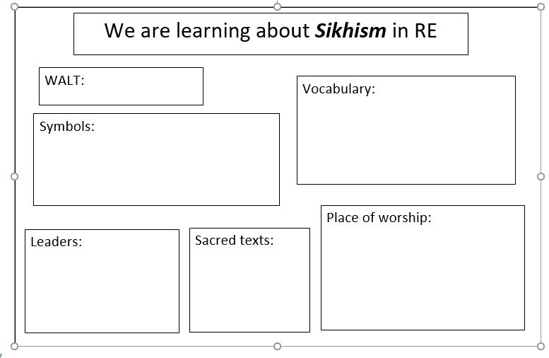

Appendix 7 – History

We are learning about ___________________________________________in History
WALT:
Chronology: When did it happen?
Vocabulary:
Questions:
Who
What
Where
Sources of Information:
How do we know?
Similarities and Differences.

Appendix 8 – Design Technology

Research | Design | Make | Evaluate
Focused Tasks (FTs)
Investigative and Evaluative Activities (IEAs)
Design and Make Activity (DMA)
Key Vocabulary
Word | Meaning
We are designing and making ______ (product) for ______ (user) for _________ (purpose).
Strand of DT
Eg Mechanical Sytems/Food/
Textiles/Electrical Systems etc.
Inventor/Designer Focus
We are exploring the work of ……..

Skills Focus
Design and Technology Working Wall

Appendix 9 – PE

Year 1  WALT: To make decisions and create various animal shapes | Year 2  WALT: To develop balancing techniques
Vocab: Skills:  To be written on weekly | Vocab: Skills:  Today we will be discussing AGILITY
Evaluation:  This will be done each week  written in pen. | Evaluation:

Appendix 10 – Computing
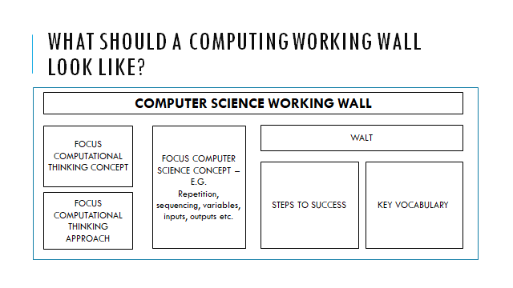

Appendix 11 – Art & Design
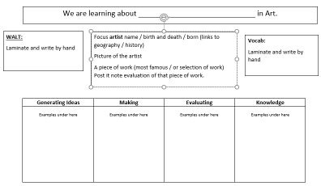

Appendix 13 – Music
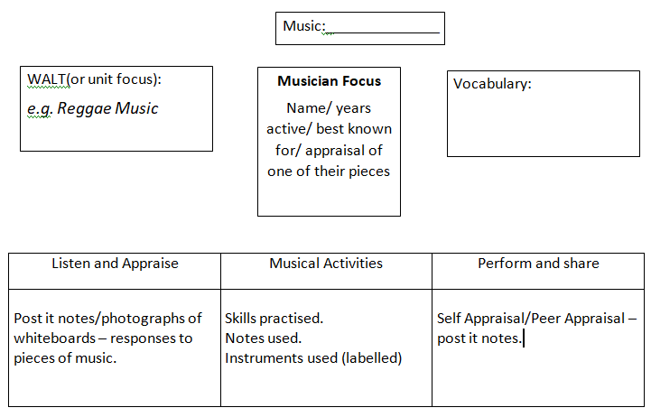

Appendix 14 – EYFS Literacy
OUR LITERACY WORKING WALL
PROBLEM:

SOLUTION:
TITLE:
AUTHOR:
Picture of front of book or story map
ILLUSTRATOR:

CHARACTERS:
Names:
Traits:

SETTING: VOCABULARY: linked to that book

OUR FOCUS: eg. Full stops, capital letters, spaces between words etc.

Appendix 15 – EYFS Maths

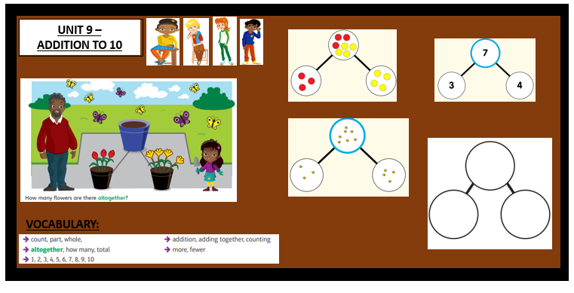

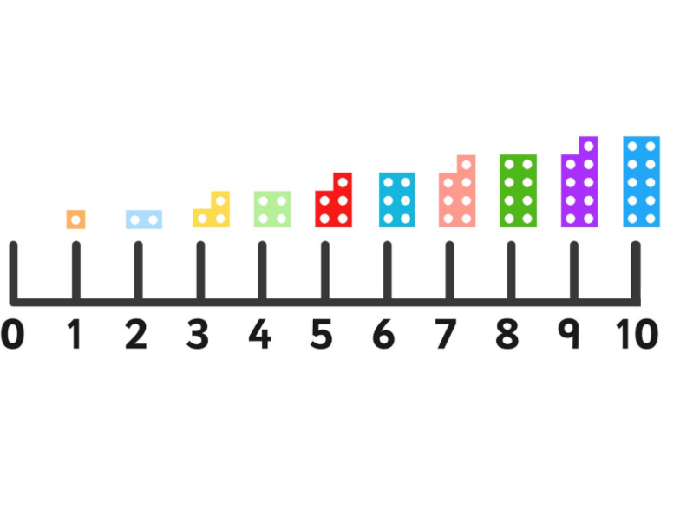
Appendix 16 - Science working wall
WALT
Grouping and classifying
Observing and measuring
Seeking Patterns
Fair Test
Scientific Vocabulary
Scientific Knowledge

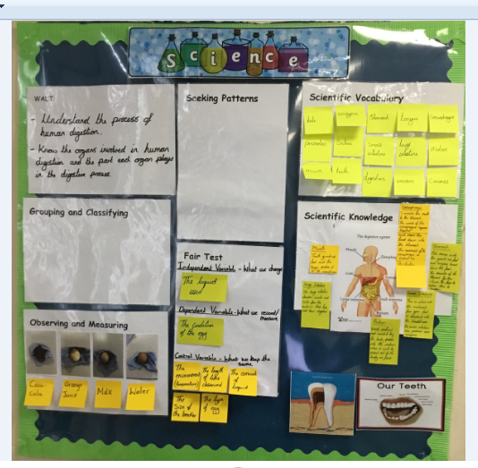

Appendix 17 – Reading Board
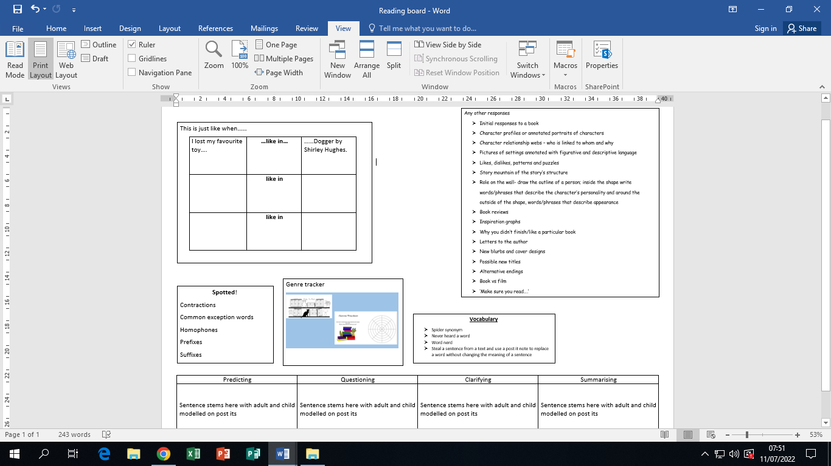

Appendix 18 - MFL

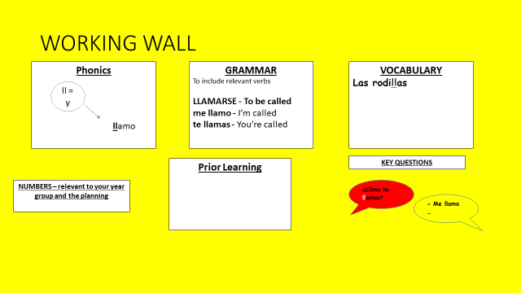
Appendix 19 - Time To Talk – Rationale and Template
As you will see from the design, it's really simple, in year 1/2 the children can pop their peg on the board if they need to talk, in EYFS, they could perhaps use a picture of the children, if it makes it easier for them to identify. The template that follows should be printed on A3 paper and laminated within the classroom.
I need to
talk…

Appendix 20 – Phonics RWI



