Fazakerley
Primary School

Formosa Drive, Liverpool, L10 7LD

Handwriting Policy

Our School Mission Statement
In order to achieve success at Fazakerley Primary School, we believe that everyone in our community is of equal worth and should be given the opportunity to develop their full potential intellectually, emotionally, socially, physically and professionally. We promote in our whole school community, an understanding and respect for everyone’s well-being and mental health, valuing and supporting each other as an integral part of our school life.

Introduction
This guidance has been written in line with the statutory requirements for Handwriting across Key Stage 1&2, National Curriculum for English 2014. Handwriting is a skill which, like reading and spelling, affects written communication across the curriculum. Children must be able to write with ease, speed and legibility. Cursive handwriting teaches pupils to join letters as a series of flowing movements and patterns.
A consistently high standard of presentation and handwriting is promoted across the whole school which all pupils and staff recognise, understand and follow.

Objectives
- To be able to maintain a correct pencil/pen grip and posture, positioning themselves correctly whether they are left or right handed
- To be able to correctly form lower and upper case letters
- To know the correct entry and exit points of letters
- To be able to write letters and words showing regularity and spacing
- To develop an ability to join letters in words by building upon their knowledge of letter formations
- To develop a neat, legible style with correctly formed letters and cursive handwriting
- To develop fluency and speed whilst writing
- To develop a sense of pride in their work, enabling them to present their work neatly to an audience

Whenever handwriting is modelled by the adult (including on whiteboards/displays/resources as well as when teaching it) it is modelled using the appropriate joins, demonstrating the fluency and legibility.
Handwriting is taught discreetly in short, regular sessions. These sessions are adult led and include the explicit modelling of writing to the whole class. It is practised in KS1 and KS2 during guided reading carousel. The teacher models effective pencil/pen control under the visualiser so that the children can see close up, how the strokes are formed. Opportunities for linking handwriting with phonics and spellings are taken. Handwriting books are used in year 1 and 2, in KS2, handwriting goes into the guided reading carousel book. School use the resource ‘PenPals’. This is a handwriting scheme, offering clear progression through five developmental stages and starts from Reception in EYFS and goes to Year 6. It teaches children a fast and fluent handwriting style to help them achieve their potential in writing.

EYFS
Children experience a wide range of handwriting skills, e.g. letter and number formation in sand trays, tracing, use of ribbons, chalk, felt tips, pencils, crayons, writing over and under teacher models in various forms, word building with magnetic letters and pattern making in various media.
Correct sitting and pencil grip is taught.
Children are taught to write in a straight line from left to right.
By the end of Reception, pupils are expected to form letters, including upper case using exit points only. In reception, the children use handwriting practice books used during the guided group activity.

Year 1
By the end of year 1, pupils are expected to use entry and exit points (pre cursive).
Pupils should be taught to:
- sit correctly at a table, holding a pencil comfortably and correctly
- begin to form lower-case letters in the correct direction, starting and finishing in the right place
- form capital letters ▪ form digits 0-9
- understand which letters belong to which handwriting ‘families’ (i.e. letters that are formed in similar ways) and to practise these.

Year 2
By the end of year 2, pupils are expected to write fully joined (full cursive)
Pupils should be taught to:
- form lower-case letters of the correct size relative to one another
- start using some of the diagonal and horizontal strokes needed to join letters and understand which letters, when adjacent to one another, are best left unjoined
- write capital letters and digits of the correct size, orientation and relationship to one another and to lower case letters
- use spacing between words that reflects the size of the letters. be able to form individual letters correctly, so establishing good handwriting habits from the beginning
- Pupils should revise and practise correct letter formation frequently. They should be taught to write with a joined style as soon as they can form letters securely with the correct orientation.

Lower Key Stage 2
Joined handwriting should be the norm; pupils should be able to use it fast enough to keep pace with what they want to say.
Pupils should be taught to:
- use the diagonal and horizontal strokes that are needed to join letters and understand which letters, when adjacent to one another, are best left unjoined
- increase the legibility, consistency and quality of their handwriting [for example, by ensuring that the down strokes of letters are parallel and equidistant; that lines of writing are spaced sufficiently so that the ascenders and descenders of letters do not touch].
- Pupils should be using joined handwriting throughout their independent writing. Handwriting should continue to be taught, with the aim of increasing the fluency with which pupils are able to write down what they want to say. This, in turn, will support their composition and spelling.

Upper Key Stage 2
Pupils should be taught to: ▪
- write legibly, fluently and with increasing speed by:
- choosing which shape of a letter to use when given choices and deciding whether or not to join specific letters ▪ choosing the writing implement that is best suited for a task.
Pupils should continue to practise handwriting and be encouraged to increase the speed of it, so that problems with forming letters do not get in the way of their writing down what they want to say. They should be clear about what standard of handwriting is appropriate for a particular task, for example, quick notes or a final handwritten version. They should also be taught to use an unjoined style, for example, for labelling a diagram or data, writing an email address, or for algebra and capital letters, for example, for filling in a form.

Provision
Handwriting provision is given to those pupils whose letter formation, joining or speed requires improvement.
We use an intervention programme, ‘Write from the Start’ which is a provision that develops the fine motor and perceptual skills for effective handwriting. Adults liaise with the SENDCo to develop the right provision based on the individual needs of the pupil.

Pencil grip
Pupils should hold a pencil with a grip which is relaxed but allows for efficient pencil control. A tripod grip is an efficient way of holding a pencil/pen. It should be lightly held between the thumb and forefinger about 3cm from the point with the middle finger providing additional support.

Implements
Children write in pencil until they are awarded a Pen Licence from the Head Teacher. Class teachers decide when pupils have displayed neat and consistent cursive handwriting across the curriculum. At this point, pupils present their work to the Head Teacher who awards the pen and Pen Licence. This is a special award that is celebrated.
Use of rubber pencil grips may be used for correction of pencil hold where appropriate.
Pupils always use pencil in maths, art and for the drawing of anything whether pupils have a pen licence or not.

Assessment
Handwriting is assessed during independent written pieces of work by the class teacher. It is also assessed summatively during assessment week when the children complete a piece of dictation. Samples of children’s independent work across a range of subjects will be moderated at a minimum of three times a year at school, local and city wide moderation events.

Posture
- Chairs and desks are matched to children’s age and height.
- Children’s backs should be straight and feet resting on the floor.
- Always make sure that the hand which is not holding the pencil or pen holds the paper.

Left handed children
All adults are aware of the needs of left handed pupils and make appropriate provision.
Left handed children may find it difficult to follow right handed adults as they model letter formation (and vice versa). Adults should demonstrate to left handed pupils on an individual or group basis.
Left handed pupils should sit to the left of right-handed pupils so that they are not competing for space.
Paper should be positioned to the left for right handed pupils and to the right for left handed pupils and slanted to suit the individual in either case.
Pencils should not be held too close to the point as this can interrupt pupils line of vision.
Presentation
Pupils should be reminded to always take pride in their work. Books should be taken care of with no marks on them other than children’s neatly presented work. Any crossing out should be done neatly with a ruler. Rubbing out should be done carefully so pages are not creased.

The following applies to how work should look in our children’s books:

- All children are encouraged to present their work to the highest standards. Progression in presentation is expected throughout the year.
- All work should be completed using a school pencil and children should be encouraged to sharpen pencils regularly to ensure neatness. School pens will be awarded to children from Year 3 alongside their pen license from the headteacher, when their handwriting is deemed to be consistent with the school’s handwriting policy in all of their books.
- The English date should be written in the top right hand corner (day, date, month)
- Next line: The title which should be in the form of - WALT: This should then be underlined right across the page from the margin.
- Children should then leave a line and their work should begin on the next line.
- MATHS: exactly the same except it is the number date written and ALL Maths work should be done in pencil and include the number date and title (All underlined)
- Stickers can also be used for the date and WALT to be printed on and placed at the top of the child’s work (adult judgement)
- Teachers must also take pride in the presentation of their marking and all marking made by the class teacher will be in red pen (I’e to model a correct letter join in the child’s book).
- Where work is marked by a person other than the class teacher, green pen is used.
- All staff must be conscious of the fact that they are modelling correct letter formation and /joins at all times.

Appendix 1: Our agreed cursive style is as below:

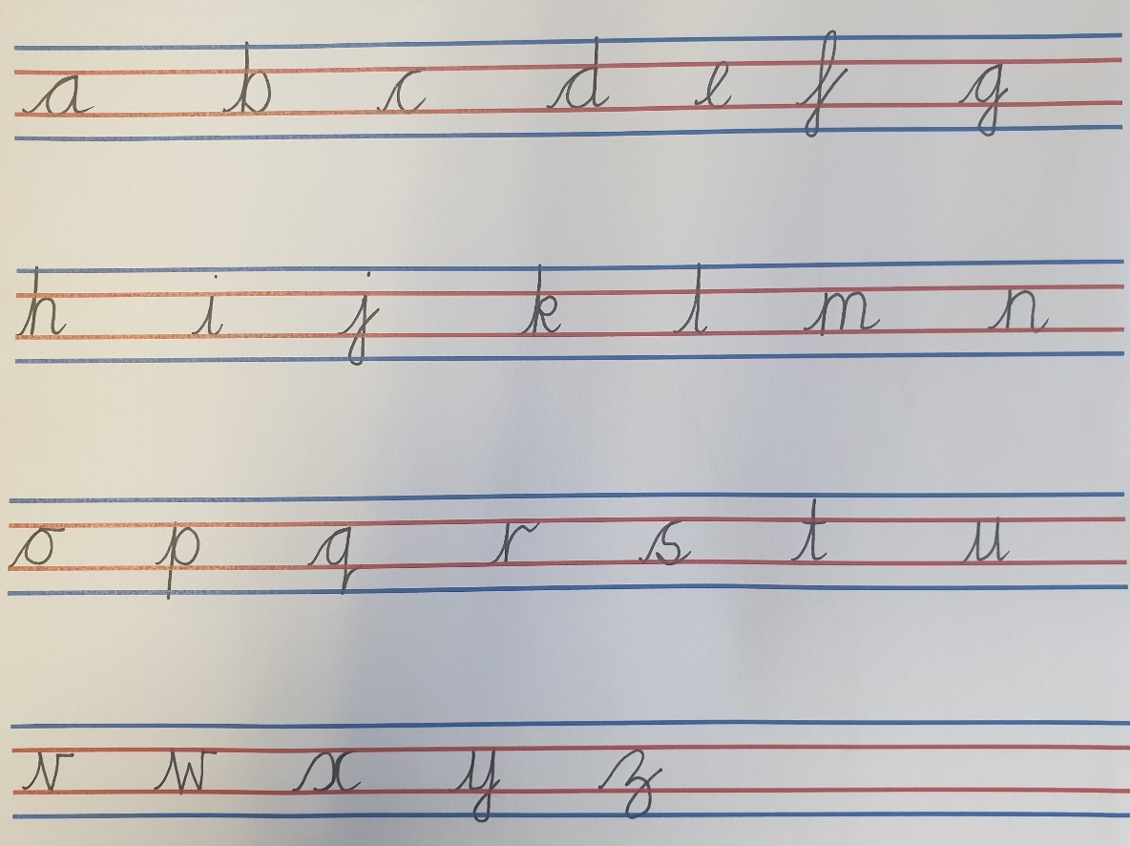

Appendix 2: Pen License
Mrs Bennett, Head Teacher is delighted to award you with your official
Pen Licence
School: Fazakerley Primary School
Name:
Date awarded:
Approved by Head Teacher:________________
WARNING:
The staff reserve the right to revoke at any time if standards fall below expectations.

